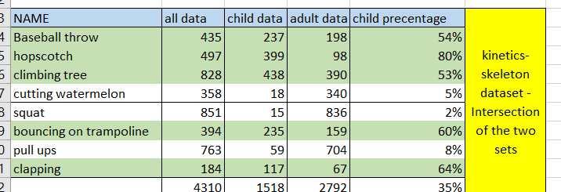

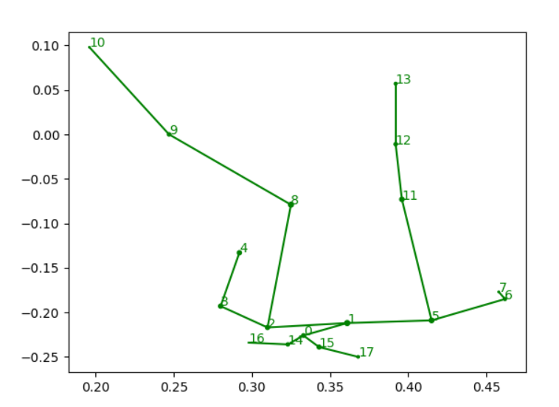

1

Body 25

After removal of 6 joints : ‘no_foot’

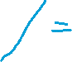

Coco structure

